**NATIONAL UNIVERSITY OF SCIENCES AND TECHNOLOGY**

MILITARY COLLEGE OF SIGNALS

**(CAMPUS OF NUST)**

**

**GROUP #9 PROJECT :**

**Not Food Panda**

An Online Food Ordering System

**SUBMITTED TO:**

Sir Nauman Ali Khan

**DATED :**

29-May-2023

**SUBMITTED BY:**

Amal Asim

Nimrah Kamran

Aiffa Amir

Kashaf Eman

Laiba Ghaffar

**PROJECT REPORT**

**Object Oriented Programming**

**COURSE: BE SE – 28**

**SECTION: C**

**Not Food Panda (Online Food Ordering System)**

**Abstract:**

This report presents the development process of an online food ordering system in java with user friendly interface. Our Not Food panda is designed in a very interesting way with all features that are necessary in an online food ordering system. Classes, methods, and data structures were designed to ensure seamless implementation of the desired functionality such as ordering , searching managing as admin , checkout and bill management systems.

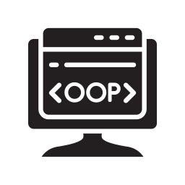**Resources Used:**

1. Vs Code and its extensions.
2. JDK (Java Development Kit 19)
3. Language: Java Swing / Java FX.
4. Intellij (Best for writing java programs).
5. Net beans for GUI (Graphical User Interface).
6. Canva for designing interfaces.
7. Internet for other resources.

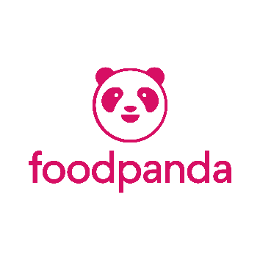**The Origin Of Food Panda** (A brief introduction):

**What is an ONLINE FOOD ORDERING SYSTEM?**

An online Food ordering System is an interface between customer and restaurants making it easier to place order **ANYWHERE,EVERYWHERE!**

**The first online food ordering system was created in 19﻿94 by a company called Pizza Hut.**

**In 2012, Swiss Lukas Nagel and Rico Wyder established Foodpanda in Singapore, before expanding to Malaysia, Indonesia, the Philippines, Taiwan and Thailand.** Nauman Sikandar Mirza is CEO of foodpanda Pakistan.

**Objectives / Scope:**

1. **Convenience:** The primary objective of an online food ordering system is to provide convenience to customers. It allows them to browse menus, place orders, and make payments.
2. **Wide Menu Selection**: The system aims to offer a wide range of food options from various restaurants and cuisines to cater to different tastes and preferences of customers.
3. **Ease of Ordering**: The system should provide a user-friendly interface that enables customers to easily navigate through menus, customize their orders and specify delivery preferences.
4. **Order Tracking:** The system should offer real-time order tracking functionality so that customers can know the status of their orders, including preparation, packaging, and delivery progress.
5. **Customer Reviews and Ratings:** The system should allow customers to leave reviews and ratings for restaurants and their food, providing valuable feedback to both the restaurant owners and other potential customers.
6. **Positive Outcomes for Industry:** Easy Access to everyone and Connection to Every restaurant. Also helps in Growing / Promoting Businesses.

Open 24/7. Creating jobs. Order food from home. ***Works as small website for startups who cannot afford to manage their own website****.*

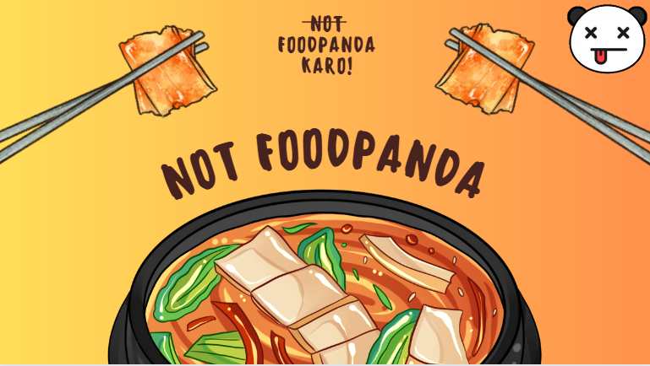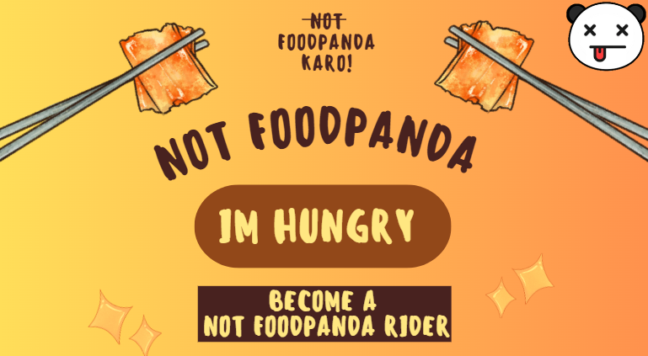

**OUT OF SCOPE:**

1. **Prices of food** cannot be decided by an ordering system.
2. **Menu** is decided by Restaurants.
3. **Food preparation** is out of scope.
4. **Restaurant** information and deals is not handled by system ,it comes under the responsibility of restaurant.

**IMPLEMENTATION:**

**1. Login / Sign up Page :**

With a user-friendly interface, the Login page provides a smooth login experience. User can login and sign up and its information will be save and its account will be made available .With this functionality the data of user will be saved and this interface will let user enter in not food panda and its all past orders will be saved.

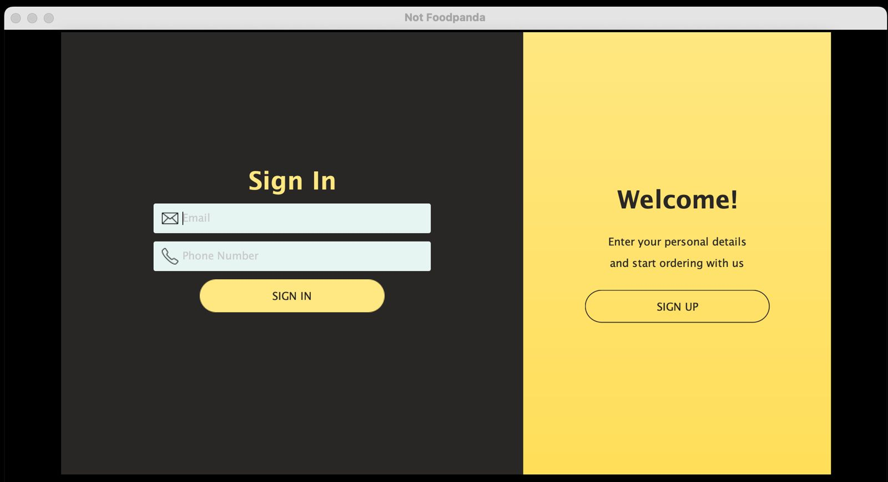

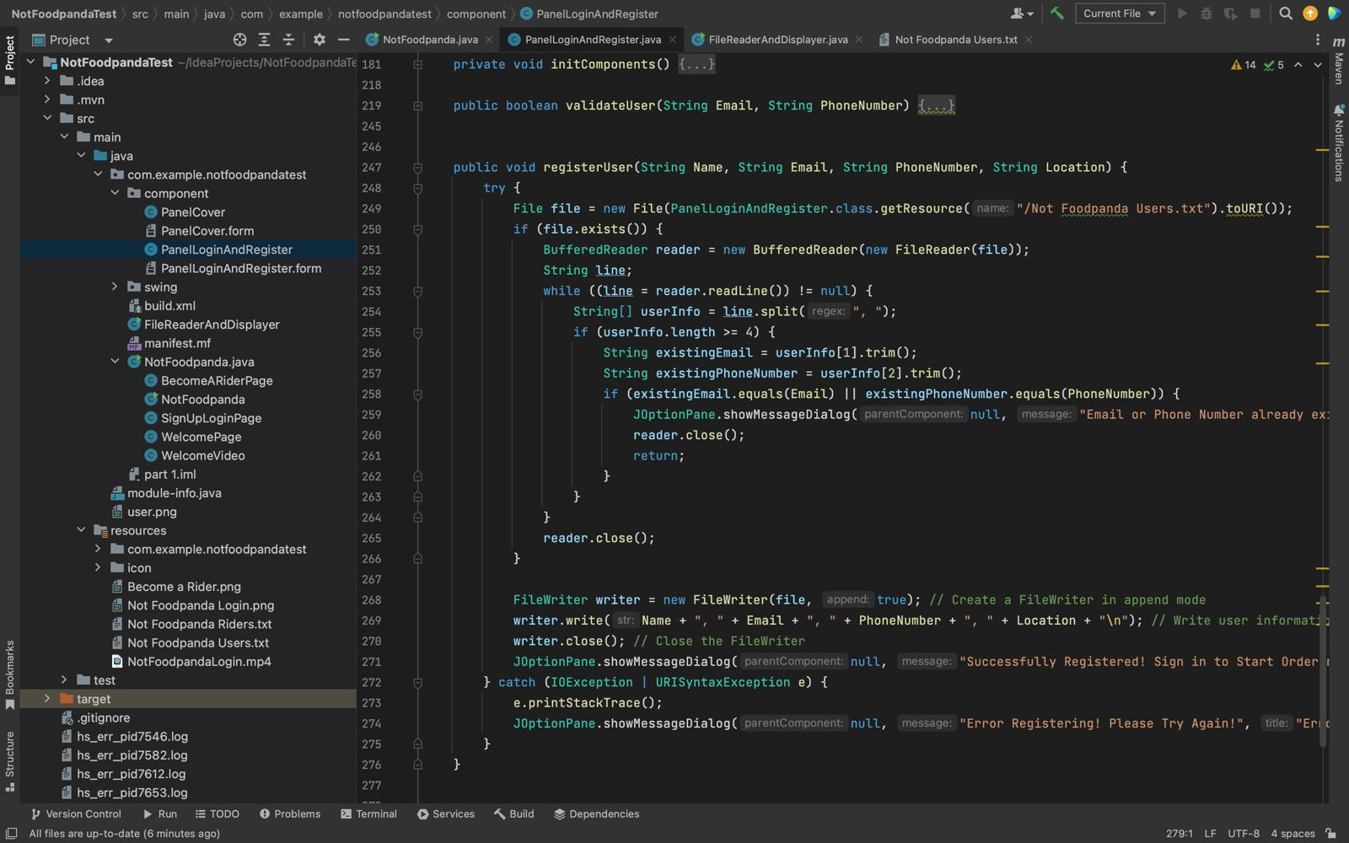**EXECUTION:**

1. **Register as Not Food Panda Rider :**

To become a rider in an online food ordering system, interested individuals need to complete a registration process.The process may require providing personal details, contact information, and necessary identification documents.

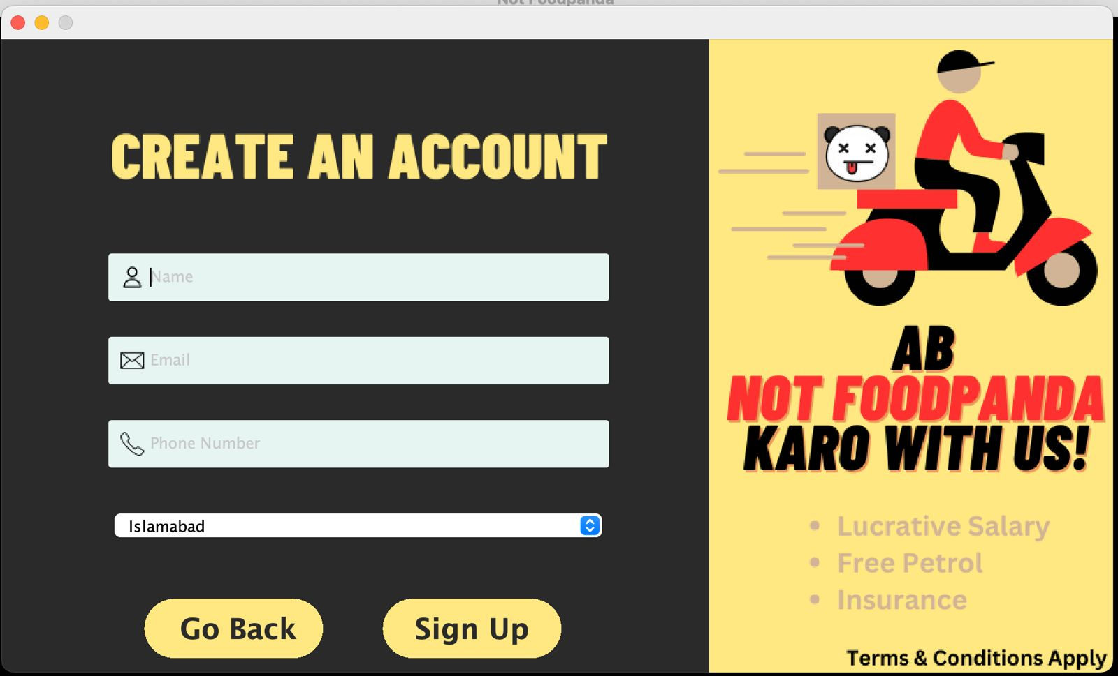

**3. RESTAURANTS :**

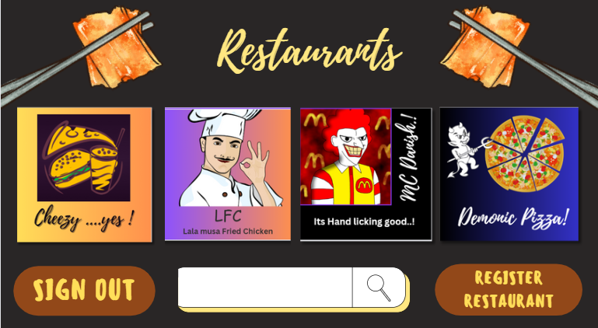The main page of a restaurant's online food ordering system should reflect the restaurant's brand identity and create an appealing visual experience for customers. It should feature the restaurant's logo, color scheme, and overall aesthetic to establish a sense of familiarity and reinforce brand recognition. So we have fulfilled all this in our page.

**Clear and Intuitive Navigation:**

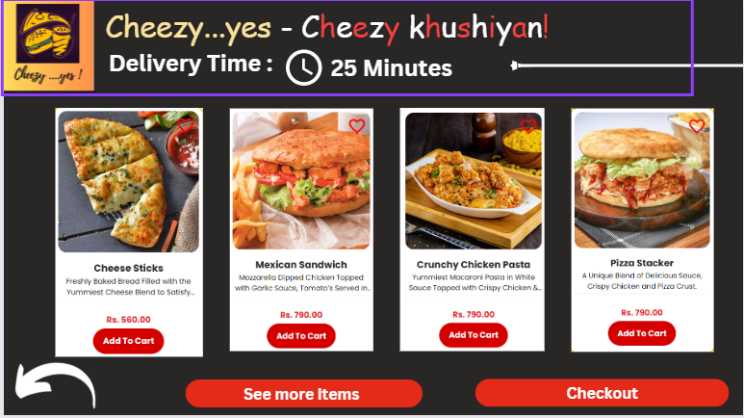The main page should have a well-organized and intuitive navigation menu that allows customers to easily browse through different sections, such as menus, special offers, and account settings. Clear labels and visually distinct buttons or icons should be used to guide customers through the ordering process.

Screenshot of our LFC Restaurant:

**4. Cart Mangement :**

The cart in this application will work in a way that it will help user to use checkout option. It will show User choice and the accessories in the list user will be able to edit it’s cart items and save them.

**EXECUTION:**

There will be a parent class name cart.java that will be inherited by two subclasses order info and edit selection . In order info class there will be three functions Restaurant selection, Selected Items and receipt . These functions will be implemented in java swings in the form of buttons ,when the buttons will be clicked they a new interface will open up for that specific functionality.

On the other hand we have a subclass Edit selection with functionalities of editing items implemented in the form button that will take the user to an interface where the user can edit it’s selection and save it and a functionality of comments that will be implemented as a text box

Where user can write it’s comments and both the subclasses have a common function of receipt that will show the final receipt of users items.

**5. Order Tracking:**

It will ask for order number search in the restaurant record, look for the id fetch the info and show that to user.

There will be class tracking.java having two methods of order details and delivery timing, this whole class will be shown in the form of a java form showing the estimated delivery timing that will be set by restaurant and order status will also be updated by the restaurant from time to time. The options for status updates will be order has been received, the restaurant is preparing your food, order has been picked up for delivery or order arriving soon.

**EXECUTION:**

**OOP Concepts implied:**

As the project was based in Java so many OOP concepts are implied. These are:

Classes

Objects

Abstraction

Polymorphism

Encapsulation

**Classes:**

Classes are the basic blueprints. The main data is stored into the classes. It is the basic diver code. Classes are significant in data storing. This concept is implied in the project to help it work well. Many classes are implied here namely:

Restaurants.java

Cart.java

Login.java

**Objects:**

Objects are the instances of the java classes. They can be termed as the copy of the specific class. Objects carry all the properties of the object they belong to. The objects here are used to fetch the information of the specific class. For example: An object of the class restaurants is implied to get to the new page of cart as:

Cart obj=new Cart():

obj.setVisible(true);

this.dispose;

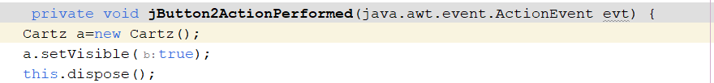

**Encapsulation:**

Encapsulation is another way of hiding information. It is relatively easy to imply the information by this means. It simply gets the information in the getters and set it to a specific value by the setters. The concept is implied to get the item prices.

public void getPrice(){

return Price;}

public int setPrice(int newPrice){

newPrice=price;

}

**Abstraction:**

This is the way to hide specific information from the user. The abstract class is parented to a child class in which the specific methods are introduced to help fetch the information and then imply it. The login method is based in this technique.

**Polymorphism:**

Polymorphism literally means “different shapes”. The concept is the basic implementation of overriding and overloading. This technique helps us in the way that class can provide the different implementation of the method depending on the type of the object passed to the method. It helps us to perform the same task in different ways.

**Inheritance:**

Inheritance means to “get properties from ancestors”. In inheritance, the child class gets properties from the parents. It helps to avoid creating the code again and again and helps reusing the same code.

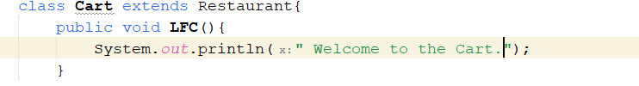

**Answer of Potential Questions:**

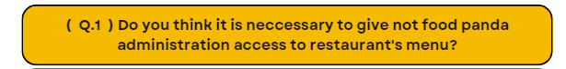

Yes, it is necessary to give the online ordering system administration access to the restaurant's menu. This access allows the restaurant to have control over the menu items and make necessary updates or changes. By having administration access, the restaurant can ensure that the online menu accurately represents their offerings and prices.

Additionally, administration access enables the restaurant to manage inventory, track sales data, and analyze customer preferences, which can be valuable for decision-making and business optimization.

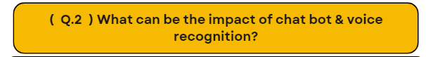

1. **Enhanced Customer Experience**: Chatbots provide instant responses to customer queries and support, improving the overall customer experience. They can handle multiple inquiries simultaneously, provide personalized recommendations, and offer 24/7 assistance, leading to faster and more efficient interactions.
2. **Improved Order Accuracy**: Voice recognition technology allows customers to place orders by speaking directly to the system. This reduces the chances of miscommunication or errors that can occur when taking orders manually. Voice recognition can accurately capture order details, including specific customization requests, ensuring order accuracy.